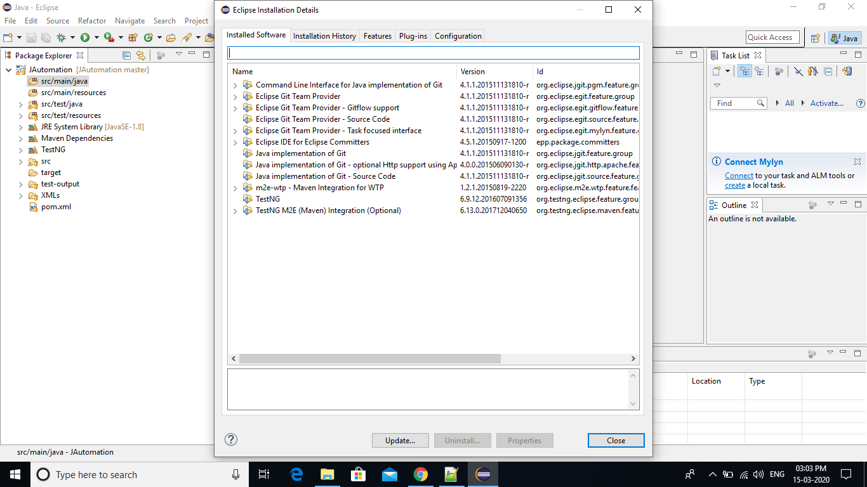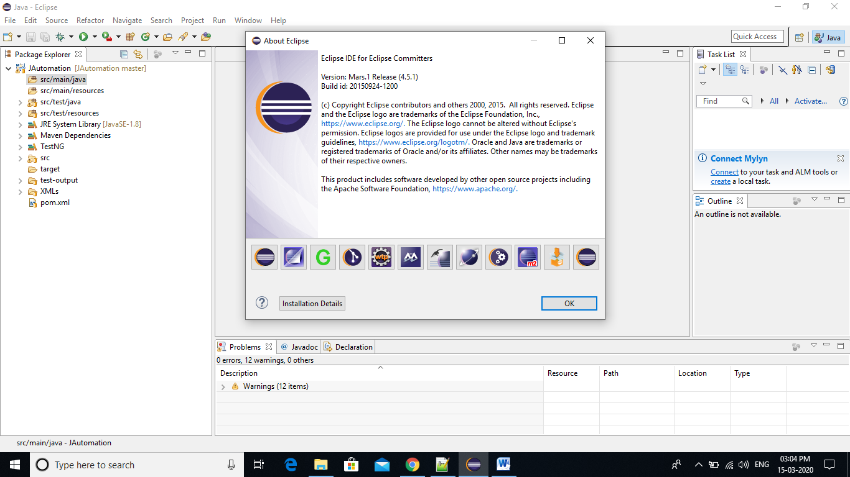

Settings.xml File

<?xml version="1.0" encoding="UTF-8"?>

<settings xmlns="http://maven.apache.org/SETTINGS/1.0.0"

xmlns:xsi="http://www.w3.org/2001/XMLSchema-instance"

xsi:schemaLocation="http://maven.apache.org/SETTINGS/1.0.0 http://maven.apache.org/xsd/settings-1.0.0.xsd">

<pluginGroups>

</pluginGroups>

<proxies>

<proxy>

<id>optional</id>

<active>true</active>

<protocol>http</protocol>

<host>proxy.javacodegueeks.com</host>

<port>9000</port>

<username>proxy_user</username>

<password>user_password</password>

<nonProxyHosts>*.google.com|javacodegueeks.com</nonProxyHosts>

</proxy>

</proxies>

</settings>